**Assignment 1**

1. Install Jupyter notebook and run the first program and share the screenshot of the output.

**Solution:**

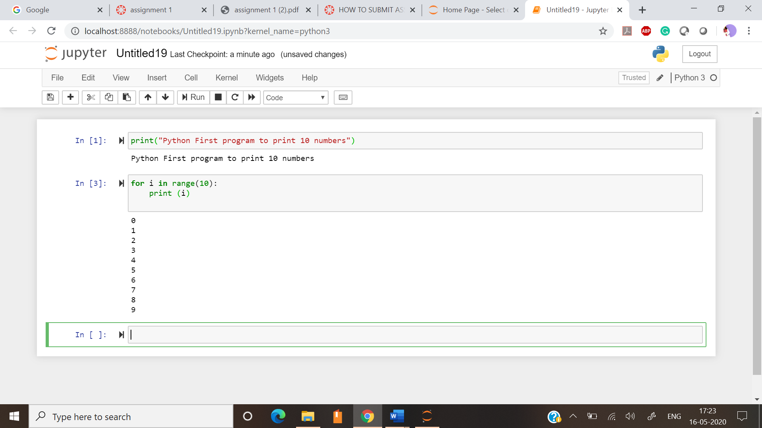

1. Write a program which will find all such numbers which are divisible by 7 but are not a multiple of 5, between 2000 and 3200 (both included). The numbers obtained should be printed in a comma-separated sequence on a sing.

**Solution:**

for i in range(2002,3201):

if i%7 == 0 and i%5 != 5:

print(i, end=' ')

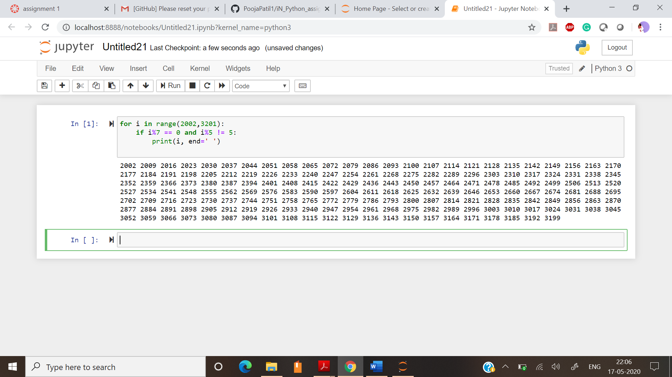

1. Write a Python program to accept the user's first and last name and then getting them printed in the the reverse order with a space between first name and last name.

**Solution:**

first_name = str(input("Enter first name:"))

last_name = str(input("Enter last name:"))

print(first_name[ : : -1 ] + " " + last_name[::-1])

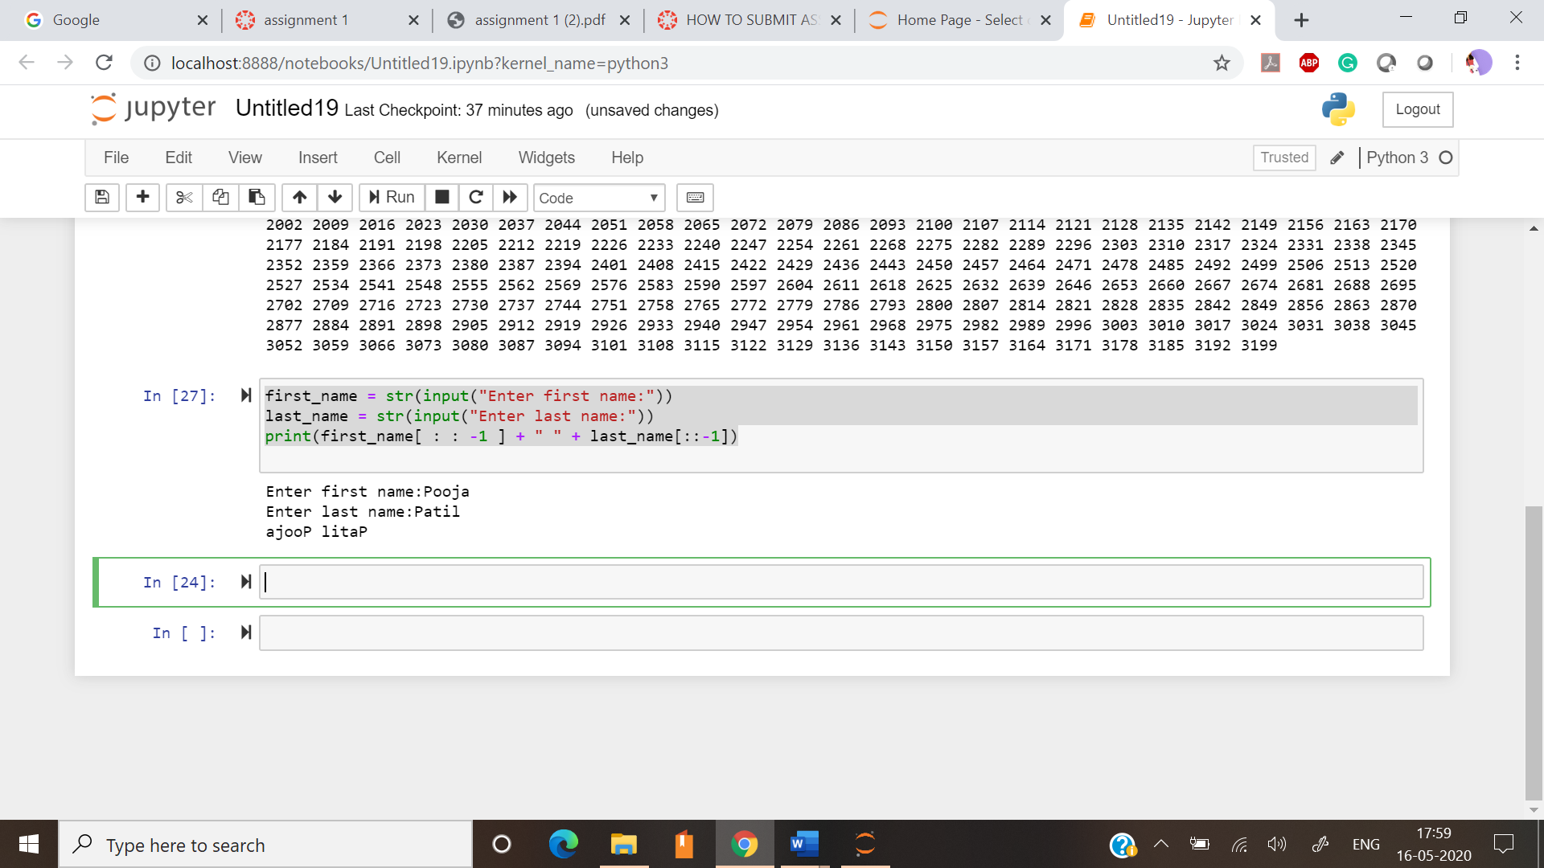

1. Write a Python program to find the volume of a sphere with diameter 12 cm. Formula: V=4/3 * π * r 3

**Solution:**

volume= (float(4/3))*(22/7)*(float(12/2)**3)

print(volume)

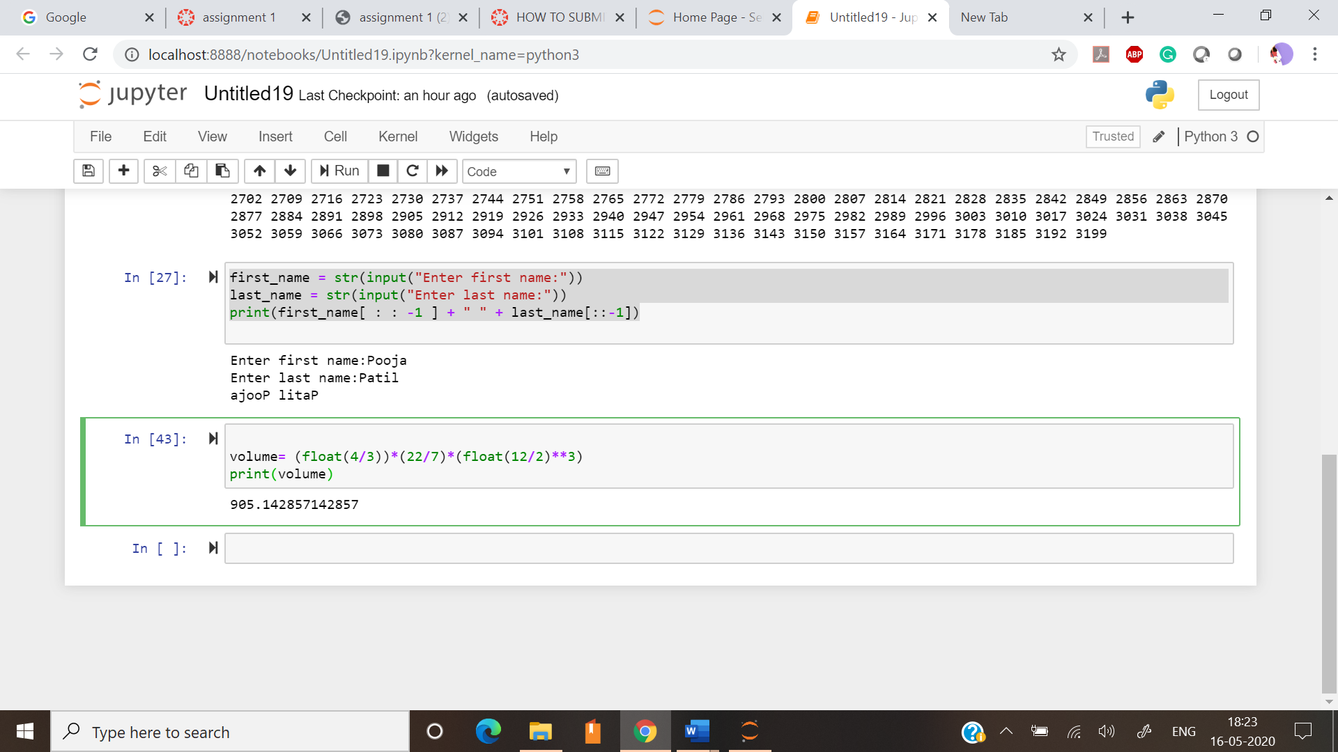

Task 2:

1. Write a program which accepts a sequence of comma-separated numbers from console and generate a list.

**Solution:**

input_str = str(input())

l = input_str.split(',')

print(list(l))

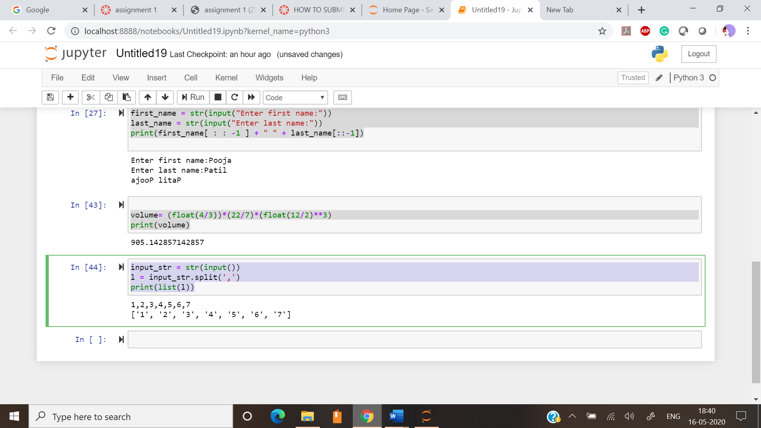

1. Create the below pattern using nested for loop in Python.

**Solution:**

for i in range(0,5):

for j in range(0,i+1):

print("*",end = ' ')

print("\r")

for i in range(5, 0, -1):

for j in range(0, i - 1):

print("*", end=' ')

print("\r")

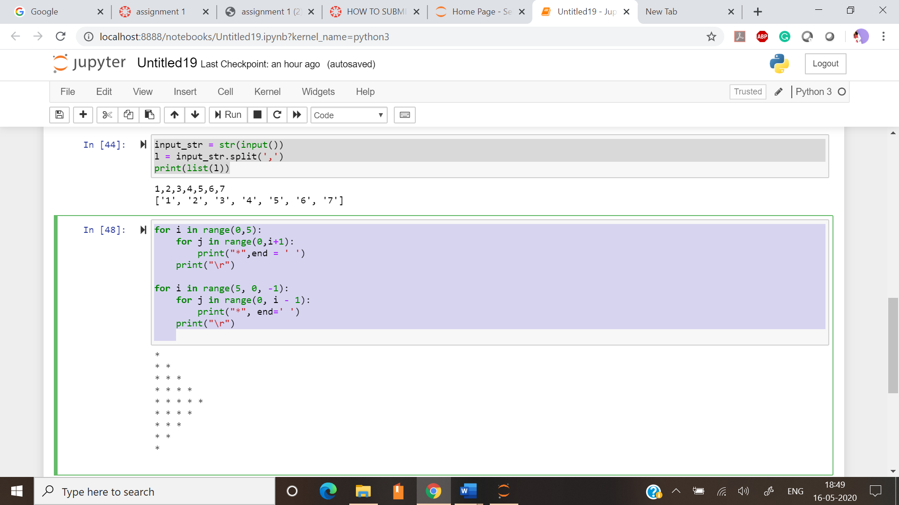

1. Write a Python program to reverse a word after accepting the input from the user.

**Solution:**

inp_string = str(input("Enter sting to reverse:"))

print(inp_string[::-1])

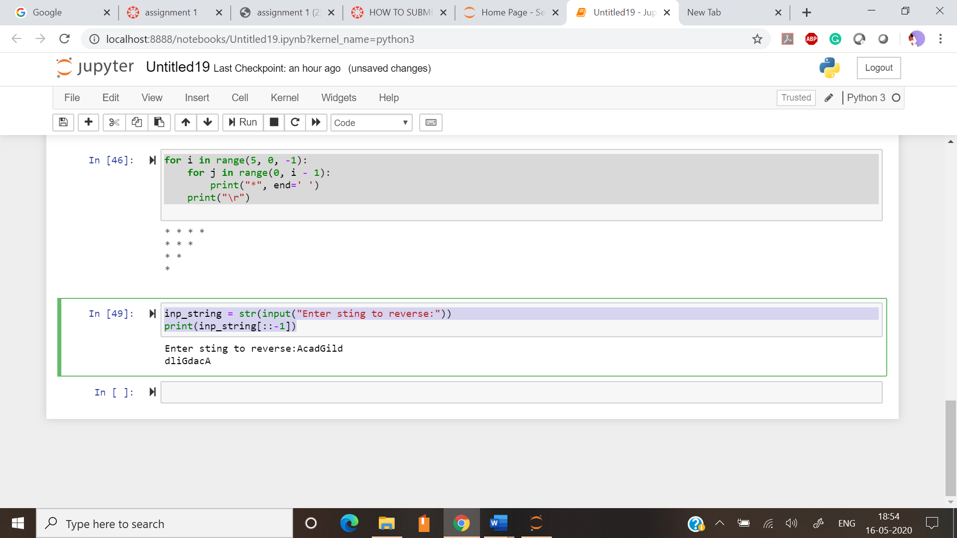

1. Write a Python Program to print the given string in the format specified in the sample output. WE, THE PEOPLE OF INDIA, having solemnly resolved to constitute India into a SOVEREIGN, SOCIALIST, SECULAR, DEMOCRATIC REPUBLIC and to secure to all its citizens

**Solution:**

print('WE, THE PEOPLE OF INDIA,\n\thaving solemnly resolved to constitute India into a SOVEREIGN,! \n\t\tSOCIALIST, SECULAR, DEMOCRATIC REPUBLIC \n\t\t and to secure to all its citizens')

